**PROJECT REPORT: SIMPLE CONTACT BOOK APPLICATION**

**1. Introduction**

The Contact Book Application is a simple program that allows users to manage a list of contacts. The application is implemented in Python and uses SQLite as the database to store contact information. Users can perform various operations such as adding new contacts, editing existing contacts, deleting contacts, searching for contacts, and viewing all contacts.

**2. Features**

**2.1 Database Management**

* The application uses SQLite to manage a database named **contacts.db**.
* A table named **contacts** is created to store contact information, including fields such as **id**, **name**, **address**, **phone**, and **email**.

**2.2 Contact Operations**

1. **Add Contact (add_contact function):**
   * Users can add new contacts by providing details such as name, address, phone number, and email.
   * Contacts are stored in the database.
2. **Edit Contact (edit_contact function):**
   * Users can edit existing contacts by specifying the contact ID and providing new information for the contact.
   * The application retrieves existing values and allows users to update specific fields.
3. **Delete Contact (delete_contact function):**
   * Users can delete a contact by specifying the contact ID.
   * The application removes the contact from the database.
4. **Search Contact (search_contact function):**
   * Users can search for contacts by entering a search term (name or email).
   * The application displays matching contacts based on the search term.
5. **View All Contacts (list_contacts function):**
   * Users can view a list of all contacts stored in the database.

**2.3 User Interface**

* The user interface is implemented using a simple text-based menu.
* Users interact with the program by entering numeric choices (1-6) corresponding to different menu options.

**3. Implementation**

* The application is implemented in Python.
* SQLite is used for database operations.
* Functions are defined to encapsulate different operations, promoting modular and readable code.
* A global variable (**loop**) is used to control the main program loop.

**4. Contact Book Usage Instructions:**

1. **Main Menu:**
   * When you start the program, you'll see the main menu with options from 1 to 6.
2. **Add a Contact (Option 1):**
   * Choose option 1 to add a new contact.
   * Enter the contact details when prompted: name, address, phone number, and email.
   * After adding a contact, you can go back to the main menu or exit.
3. **Edit a Contact (Option 2):**
   * Choose option 2 to edit an existing contact.
   * View the list of contacts and note the ID of the contact you want to edit.
   * Enter the ID and provide new details for name, address, phone, or email.
   * After editing, you can go back to the main menu or exit.
4. **Delete a Contact (Option 3):**
   * Choose option 3 to delete an existing contact.
   * View the list of contacts and note the ID of the contact you want to delete.
   * Enter the ID to confirm deletion.
   * After deleting, you can go back to the main menu or exit.
5. **Search for a Contact (Option 4):**
   * Choose option 4 to search for contacts by name or email.
   * Enter a search term, and the program will display matching contacts.
   * You can then go back to the main menu or exit.
6. **View All Contacts (Option 5):**
   * Choose option 5 to view a list of all contacts.
   * After viewing, you can go back to the main menu or exit.
7. **Exit the Program (Option 6):**
   * Choose option 6 to exit the contact book program.
   * You will be asked to confirm if you want to go back to the main menu or exit.
8. **Invalid Choices:**
   * If you enter an invalid choice, the program will notify you and prompt you to enter a valid option.
9. **Exiting the Program:**
   * At any point, you can exit the program by choosing option 6 from the main menu.
10. **Additional Information:**
    * The program stores contacts in a database (**contacts.db**) to keep your data between sessions.

**5.5 CONTACT BOOK FLOWCHART**

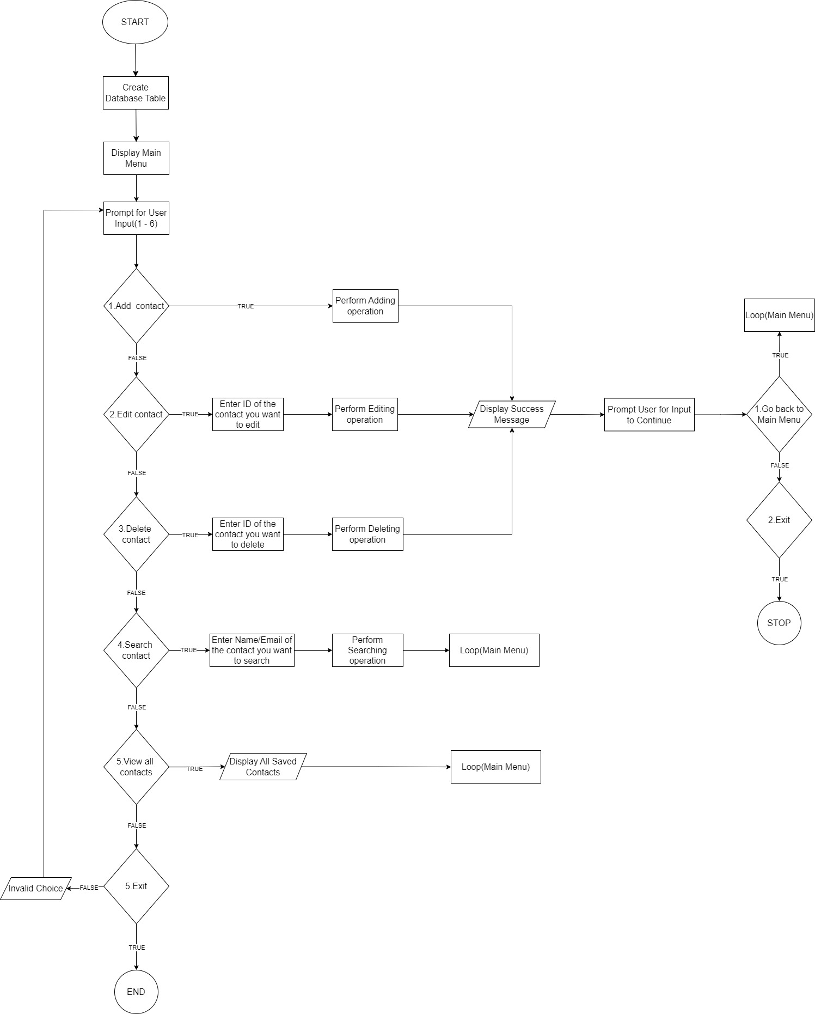

This flowchart represents the core logic of the contact book application, outlining the steps from the start of the program to its conclusion, with branches based on user choices and interactions with the database.